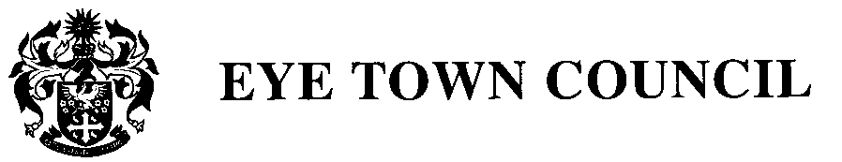

HEALTH AND SAFETY POLICY

- Introduction

1.1. This policy sets out the general principles and approach that the Town Council will follow in respect of Health and Safety legislation for premises and activities for which it is responsible.

2. Scope of the policy
2.1 The Town Council aims to protect the health, safety and welfare of employees, contractors, residents and members of the public within its area, who may be affected by the Council’s activities.
2.2. The Town Council will ensure that any buildings and amenities belonging to the Council are properly managed by the Council and that the Council set up and monitor appropriate Health and Safety policies and procedures for the protection of the public.
2.3. Councillors are required to take reasonable care of their own Health and Safety when
carrying out duties on behalf of the Town Council.

3. The Town Clerk
3.1 If the Town Clerk works from home, he/she must ensure that he/she works in a safe working environment.
3.2 This includes observing the legal recommendations for safe handling, the use of computer equipment, and workstation design.

4. Contractors, Employees and Volunteer Workers.
4.1. The Town Council will ensure that any contractors or Volunteer Workers employed to carry out work on behalf of the Council have adequate and appropriate Public Liability insurance.
4.2 Contractors and Volunteer Workers will report to the Clerk or any nominated Councillor any hazard or situation encountered during their work, which may affect members of the public.
4.3 Employees, Contractors and Volunteers should:
- Seek advice on safety and health matters from the Clerk.
- Make proper use of protective clothing and safety equipment provided.
- Report immediately to the Clerk any defects in plant, structures, equipment or safety
- procedures which come to their notice.
4. Report promptly to the Clerk any incidents which have led or might lead to injury or damage and co-operate with any investigation which might be undertaken with the object of preventing accidents or re-occurrence of incidents.
4.4 Employees and volunteers are reminded that they have a duty to care for their own safety and that of other workers and other persons who might be affected by their activities and to cooperate with the Council so as to enable it to carry out its own responsibilities successfully. The final level of responsibility is, however, that of each and every individual.
4.5 A copy of this statement will be issued to all Council employees and Councillors. It will be
revised added to or modified from time to time.

5. Roads and footpaths
5.1 The Town Council is responsible for monitoring the safety of roads and footpaths in its area, and will promptly report any hazards that are brought to its attention to the appropriate authorities for further action.

6. Environment
6.1 The Town Council will ensure that, as far as possible, the Town remains a safe and pleasant environment for its residents.
6.2. The Town Council will obtain specialist technical and Health and Safety advice for any
projects or pieces of work that could affect the general public.
6.3 The Council will ensure that any work activities carried out on its behalf do not unreasonably jeopardize the Health and Safety of the general public.

7. Risk assessment
7.1 The Town Council will carry out a risk assessment of all its activities and review this
annually.
7.2 The Council will set up and monitor policies and procedures to reduce any risks that are
identified.

8. Council Safety Officer
8.1 The Clerk, as the appointed Safety Officer will:
- Assume the day to day responsibility of ensuring the safety policy is reviewed, maintained,
- regularly reviewed and adhered to.
- Ensure that regular risk assessments are carried out of working practices, with subsequent
- consideration and review of any necessary corrective/protective measures. Maintain a file of risk assessments, summarised in the Minutes.
- Make effective arrangements to ensure those contractors or voluntary helpers working for the Council comply with all reasonable Health and Safety at Work requirements. All contractors will be given a copy of the Council’s Health & Safety at Work Policy.
- Maintain a record of notified accidents.
- When an accident or hazardous incident occurs, take immediate action to prevent a
- recurrence or further accident and to complete the necessary accident reporting procedure.
- Act as the contact and liaison point for the Health and Safety
- Inspectorate and obtain specialist technical advice and assistance on matters of Health and Safety where necessary.

9. Review of the policy
9.1. This policy was adopted by the Town Council at its meeting on 18th September 2019 and will be reviewed annually thereafter.

