Eye Neighbourhood Plan
Infrastructure Investment Plan May 2018 v0.1
Introduction
- This paper is based on the evidence of infrastructure need provided by the people of Eye. It records other indications of infrastructure requirements and compares these indicators with committed provision. Finally it captures current information about possible improvements, there costs and possible sources of funding for implementation.
Public Views of Infrastructure Needs in Eye
Views in 2015
- The people of Eye were consulted by the District and Town Council about the proposal for 280 dwellings south of Eye Airfield in 2015. People were asked what facilities and services were already in need of improvement before any further population increases. Table 1 shows that the priorities for improvement were the surgery, the primary school, shops and services, car parking and sports facilities:
Table 1 - Appraisal of current services in Eye 2015
 |  |  | ADEQUATE | NEED IMPROVEMENT | INADEQUATE
Doctor's Surgery |  |  | 11 | 29 | 26
Primary School |  |  | 5 | 21 | 5
Secondary School |  |  | 8 | 16 | 9
Play group pre-school |  |  | 6 | 4 | 3
Equipped play areas |  |  | 2 | 6 | 24
Broadband |  |  | 3 | 11 | 33
Sports facilities |  |  | 4 | 13 | 7
Open space/amenity space |  |  | 12 | 5 | 2
Car parking |  |  | 6 | 18 | 10
Public transport |  |  | 3 | 6 | 23
Church |  |  | 9 | 3 | 0
Town Hall |  |  | 5 | 9 | 6
Shops and services |  |  | 7 | 20 | 8
Street lighting |  |  | 16 | 3 | 12
Public rights of way |  |  | 10 | 7 | 6
Views in 2017
- At a drop in event to obtain residents views on the District Councils Local Plan Document organised by the Town Council attended by about 100 people, people were asked their views on what infrastructure improvements would be required. The top priorities were:

- Traffic in the town, now and how it would get worse with more development, the need for a 20 mph area and/or HGV controls.

- The need to increase the capacity of schools with some specific suggestions for how this can be achieved.

- The need for adequate doctors/local surgery capacity.

- Parking control, 'misuse' of parking, the need for more parking in the town centre and a suggestion for edge of town parking.

- How busy the A140 is, difficulty in accessing it and suggestions for improvements.

Views in 2018
- During the first phase of consultation on the Neighbourhood Plan Eye residents were asked to indicate which facilities in the Town most needed improvement.
- Hartismere Hospital 19%
- Car Park Toilets 13%
- Car Parks 10%
- Post Office 8%
- The Surgery 6%
- Moors Playground 6%
- Library 4%
- Supermarkets 4%
- Community Centre 4%

- They were also asked a series of questions about facilities and infrastructure in the Town. There was:
- Strong support for the provision of a Leisure Centre.
- Support for providing a new school on a less constrained site
- Support for better use of the Hartismere Health and Care facility preferably for health care.
- Support for reduced traffic and speeds in the town centre and better pedestrian facilities.
- Some support for new cycleways and footpaths.
- Very strong support for car parking to be better used and for more car parking to be provided.
Other Evidence of the Need for Investment in Local Facilities
- In 2014 Consultants working for the District Council on the Community Infrastructure Levy scheme (CIL) calculated the infrastructure requirements associated with the then proposal for 280 dwellings south of the Airfield. Table 2 below shows these requirements alongside the provision included in the section 106 agreement for that development. The latter makes provision for increased school places but despite the need for play areas and sports facilities identified by local people and by the District Council’s own consultants and the need identified by local people for better car parking very little provision for community facilities, play areas and sports facilities were negotiated by the District Council in the section 106 agreement.
Table 2 – Residential development south of Eye Airfield – Infrastructure Requirements

Type of infrastructure | District Council estimate of requirements | Section 106 outline requirements
Education |  | £1,768,253
Education – EY&C | £98,000 | £170,548.
Education - Primary | £700,000
Education - Secondary | £943,000,000
Health | £79,000 | £100,380
Electricity | £7,000,000
Transport | £1,000,000
(Town Centre safety |  | £50,000)
(Primary school safety |  | £15,000)
(High School safety |  | £10,000)
(Public Transport |  | £37,000)
(Rights of Way |  | £46,150)
Sports facilities | £593,000 | £100,000 (Pitch drainage and changing rooms)
Children’s play facilities | £167,000
Community centres | £149,000
Libraries | £50,000 | £60,480
Waste | £22,000
Total | £10,801,000 | £2,359,811
Primary
In Villages£
Sources: Mid Suffolk Infrastructure Plan Navigus Planning 2014 Table 11.1: Summary of infrastructure costs and figures extracted from the decision to grant outline permission for 280 dwellings South of the Eye Airfield.

- Furthermore, the District Council identifies Eye as a Market Town in its Joint Local Plan Consultation document (August 2017). In its response to this document the Town Council objected that ‘…… the case has not been made by the District Council to identify Eye as a Market Town and that the District Council should consider a different designation which might also include other small historic towns/settlements such as Debenham…’ To take one example Eye has no leisure centre but nearby Stradbroke and Debenham do have leisure centres. In granting permission for 280 dwellings in Eye the District Council has had the opportunity to redress this situation but has not done so. Despite the Councils consultants identifying a need for £593,000 to be spend on sports facilities only £100,000 for drainage of existing sport pitches/changing rooms has been negotiated in the section 106 agreement.

Redressing the Funding Gap

- Decisions by the District Council have also restricted the ability of the Town to address some of these deficits itself. Eye stands to lose out because of the Districts failure to address an application for the designation of a Neighbourhood Plan area in 2015 (it was neither approved or refused or approved with a different area). If this had been approved and a Neighbourhood Plan was in place Community Infrastructure Levy (CIL) would be payable to Eye Town Council at 25%. However without a Neighbourhood Plan, because of the District Council’s decision, CIL is limited to 15% and capped at £100 per dwelling.

- There are about 1000 households in Eye which means that the Town Council will only be able to receive £10,000 of CIL in any one year. Assuming a CIL value of £7,000 per home (which is at the lower end of the District Council’s suggested range) at the 15% rate the Town Council’s share would be £1050 per home. Therefore if more than 9 homes are developed in any one year the Town Council would receive less than it would have done had the District Council agreed the Neighbourhood Plan designation in 2015 which would have enabled the Town Council to have a Plan in place by now.

- If 15 homes are built in any one year the Town Council would have received £26,250 with a Neighbourhood Plan in place compared to the £10,000 it will receive without a Plan.

- Eye Town Council has proposed that there should be a pool available from Mid Suffolk District Council to invest in Eye at least equivalent to 25% of the CIL generated in the Town and that this be supplemented by other funding available from the District Council – Community Capital Grants – and administered by the District Council – Section 106 funding for example. Officers have consistently refused to put this proposal to District Council members.

- The District Council have proposed that the CIL money it controls will be subject to bids from relevant parties and applications will be determined in secret by the District Council. Furthermore the availability of existing/future Section 106 funding and the process of allocating is opaque at best.

- Eye Town Council’s preferred approach is:
- A joint project with the other relevant public agencies to produce an infrastructure and investment plan which enables funding to be allocated optimally and to reflect community priorities.
- To provide the people of eye with the opportunity to consider what infrastructure improvements it wants and how much development they are willing to accept to achieve those improvements.
- To access the benefits of different levels and locations of development along with the infrastructure benefits they can deliver.

- While difficulties remain in working with the District Council the County Council has indicated its support for a comprehensive plan led approach.
Preparing the Infrastructure Investment Plan
- Based upon the public priorities for infrastructure improvements outlined above the following types of infrastructure are being investigated and the costs of improvements estimated:
- The need for additional car parking space in the Town Centre.
- The need for traffic calming measures in the Town Centre.
- The need for new roads to serve new development and reduce traffic in existing residential areas (for example a north west by-pass between Victoria Hill and Castleton Way).
- The need for new cycleways and footpaths to connect the Town together and provide non car access to the Town Centre and facilities such as Hertismere School and Hospital and the Community Centre.
- The need for an additional or replacement Primary School.
- The most cost effective way to provide additional places at Hartismere High School.
- The opportunity to provide public access leisure facilities at Hartismere High School.
- The need for screening between existing and new residential development and the Airfield Industrial areas.
- The need for improvements to existing community facilities such as community centres/halls and green spaces such as the Pennings and the riverside.

- The processes to identify the potential and required infrastructure improvements include:
- Meeting with transportation planners at Suffolk County Council (being arranged) (a. to d above).
- Work with Hartismere School and Suffolk County County (e.f. and g above.)
- A survey of the improvement needs of community halls
- A meeting with the owners/managers of green spaces
- Meetings with developers and landowners.

- Site assessment and viability work (currently being undertaken by AECOM) will provide information to enable comparison of the benefits and disbenefits of various sites in and around the Town.
Prepared by Andy Robinson, Langton Brook Consultants, May 2018

NB Ben Castell – AECOM re school:
We had a quick look at primary school capacity. The headlines are:

- 183 on roll as of May 2017 (Statutory Inspection of Anglican and Methodist Schools (SIAMS) Report)
- 209 capacity taken from Edubase/ Get information establishment 3323
- Estimated child yield (0.25 for a 2 bed or more) from Suffolk’ Section 106 Developers Guide to Infrastructure Contributions in Suffolk- August 2014’. This is lower for flats (0.15), so assume the new housing on the sites in the diagram bring a need for c108 primary school places – a deficit of 134 places.

These are rough calculations but do suggest that it is wise to think about a larger site.

Appendix – Schedule of infrastructure Improvements and funding
NB This is work in progress
Section A – Community Facilities
 | Improvement | Cost | Funding source
 | Abbey Hall
 | None
 | Community Centre
1. | Heating and insulation improvements (including declaration) | £17 approx | An energy audit is required to establish what improvements are needed. Gillian will ask Ian F to undertake this.
2. | Sound Panels | £5k | This needs approval of the trustees. £1k has already been collected.
3. | Hall Floor | £4k
 | Approximate cost of projects 1-3 | £21k | The Wind Turbine Fund currently has £9.5k but a further £5k is expected. The whole £14.5k would be available for these 3 projects taken together. Gillian would also support an application for MSDC Capital Funding at 25% of the total cost – another £7k. Other sources would be needed to cover the gap, for example awards for all, but we need to look at the complete funding package to see which funding fits best where.
4. | Changing Rooms and Showers | £70k | Before funding can be considered drawings are required – ask Pro Help to start with – followed by planning permission, building control and 3 quotes. The Football Foundation and Sport England are two funding options.
5. | Play area | £70k | Consultation required leading to a design before funding can be considered.
6. | CCTV | £5k | Police fund?
7. | Satelite streaming | £2k | British Film Institute
8. | Floor Washer | £9k | MSDC Small grants fund.
9. | Driveway | £40k | Garfield Weston are offering major grants - ask them first.
10. | Projector Cage | £500 | Take from £7k savings.
 | Town Hall
11. | Improvements to Toilets | ? | Funding has been obtained for the refurbishment of the roof and for some work on the toilets. This is the funding still required to complete the toilets in summer 2018
 | Scout Hut
12. | We are looking to install a paved patio in the activity area | £750 - £1000 | Summer 2018
13. | Retaining wall and fence in need of repair | £1000 - £1500 | Urgent and immediate
13. | Ongoing redecoration/repairs) | £500 p.a | Summer 2018 – some funding available
 | Dove Hall
14. | New toilet block and permanent disabled access - A new building! The hall is 150yrs old | ?
 | Volunteer Centre
 | No improvements required
 | Bowls Club
 | Improvements subject to maintenance schedule but no immediate requirements

Section B – Leisure and Recreation Facilities
 | Improvement | Cost | Funding source
1. | Leisure centre | £? | Work is currently being undertaken to estimate the cost of converting the current sports hall and changing rooms at Hartismere High School into new classrooms and a theatre and the development of a new sports hall to be co-located with other existing sports facilities on the site. The reconfigured leisure facilities will be available to the public and managed by the School. The S106 agreement for the outline permission South of Eye Airfield makes provision of £? For additional places in the school and the School, County Council and Town Council plan to bid for CIL funding for the deficit.
2. | Pocket Park playground, Crescent
3. | Moors Playground - rec
4 | Skate Park – rec
5. | Petanque Court – rec
6. | Dog walking square - rec

Section C – School Facilities
The Town Council is in discussion about either a new school or a replacement Primary School. Land is available at Hartismere High School which would enable sharing of facilities. Costs are estimated to be:
£? For increasing the Primary School on its current site from a 240 place school to a 320 place school.
£ for a 240 place second school
£for a 480 place replacement school
£? Is allocated in the section 106 agreement for the site south of Eye Airfield for Primary School places

Section D – Movement
 | Improvement | Cost | Funding source
1. | A140 Junction Improvements | £m | The County Council has obtained grant of £m from Government and has contributed £m itself to a £m scheme to develop two roundabouts. Consultation has taken place and implementation is planned for…
2. | A 20mph limit in the Town centre | £? | The County Council will implement this scheme in summer 2018
3 | Cycleways and Footpaths | £46k | This funding is available from the Section 106 agreement for improvements to footpaths 34,11 and 6 (upgrade to bridleway), 20 and 15. Further investigation of the proposals is required and whether any funding is available for improving the riverside footpaths to enable people to get to and from the Castleton Way area including the High School, Heath and Care centre and the Local Surgery and other parts of the Town via the Town Centre.
4. | Public Transport | £35k | From S106 for bus stops on Castleton Way and Victoria Hill and real time travel information. Is/can the travel information be made available in the town centre as well?
5 | Highway safety | £70k | From s106 for safety improvements around schools and in the town centre. Likely feasibility study – consultation alongside NP phase 2 consultation?
6. | Lorry Ban | £? | The first stage would be an investigation of the number of lorries using the route. Funding would be required
7 | Castleton Way/Victoria Hill/Langley Place by pass | £3m | This is a rough estimate of the construction cost and could be looked at alongside a comprehensive north/west Eye development scheme.

Section E – Other Town Centre Facilities
 | Improvement | Cost | Funding source
1. | Car park toilets
2. | On street car parking |  | On street car parking fund
3. | Car park management
4. | New car parks
5. | Improved signage
6. | Promotion of Town Centre
7 | Church Wall
8 | The War Memorial | £2500 | The war memorial requires cleaning and it would be appropriate to complete this work before November 2018. An application for funding to the War Memorials Trust was not successful.

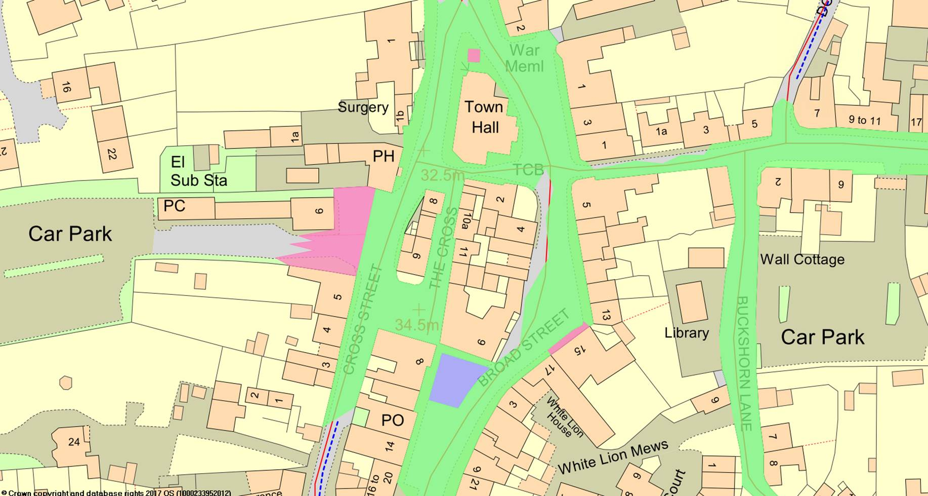

The records from our database show that the areas below in green are considered to be public highway maintainable by SCC Those ares in pink or purple are not but no information is given regarding the likely owner. Where the highway boundary does not extend to the front of buildings (eg Broad Street) this is because it has not been checked and our records updated. As explained in our meeting if you need to get a definitive answer you will need to contact our records team as they will do a full investigation. https://www.suffolk.gov.uk/roads-and-transport/road-adoption/highways-and-private-roads/

