**Prepared by Eye Goes Green. Lead author: Peter Gudde**

**Key points**

**National and regional policy landscape:**

*Road to Zero Strategy* published in July 2018[1]. The government has confirmed “*it’s ambition to see at least half of new cars to be ultra-low emission by 2030 as part of plans to make the UK the best place in the world to build and own an electric vehicle.”*

Clean Growth Strategy published October 2017. “*To meet our 2050 target, almost every car and van will need to be zero emission by 2050. The Government has announced an end to the sale of all new conventional petrol and diesel cars and vans by 2040. Walking and cycling will be made easier for many shorter journeys. By 2040, we want cycling and walking to be the natural choices for shorter journeys, or as part of a longer journey.”*

National Planning Policy Framework, revised July 2018. Section 188 states that “*applications for development should…* *be designed to enable charging of plug-in and other ultra-low emission vehicles in safe, accessible and convenient locations.”*

Local Energy East Strategy, published May 2018. Section 7 sets out plans to support clean transport networks.

UK Power Networks published their Flexibility road map – Future Smart; a smart grid for all published in July 2018. Increased power demand will in part “*be driven by EV costs reaching a point where mass take-up is feasible.”*

Suffolk County Council Highways Parking standards updated in 2015 – establishing minimum required standards for EV charging provision and design.

**EV basics**

There are three main types of electric vehicle or ‘EV’: Battery electric vehicles (BEVs), Plug-in hybrid electric vehicles (PHEVs), and range extended electric vehicles (E-REVs)[2].

Electric vehicles are zero-emission at point of use. However, emissions are produced during the generation of electricity, the amount depending on the method of generation. Therefore, the emissions need to be considered on a life cycle basis so as to include power station emissions.

For climate change gases (such as CO2), electric cars charged using average UK ‘mains’ electricity show a significant reduction in emissions. This is improving all the time, as the UK’s electricity mix is increasingly made up of a greater ratio of renewable energy.

Barriers to EV uptake include:

* Purchase price compare to conventional alternatives
* Range anxiety liked to the capacity of the battery
* Reluctance to shift to a new technology
* Lack of adequate vehicle charging infrastructure.

**Uptake and projection**

139,000 Plug-in vehicles have been sold to date in the UK with new registrations showing 27% growth in 2016-17, while plug in hybrid sales have experienced 47% growth so far in 2018. The total number of EV connectors in the UK has increased from just over 12,539 in February 2017 to more than 17,000 by July 2018.



Figure 2: EV uptake[3]

By 2030, it is forecast that between 1.2 and 1.9 million additional EVs will be connected to the South East England power network[4].

**EV Charging technology**

Currently there are three core types of vehicle charging based on the speed that they operate[5]:

* Rapid chargers are divided in two sections – AC and DC. Currently available Rapid AC chargers are rated at 43kW, while Rapid DC are typically 50kW. Both will charge an EV to 80% in around 30 minutes. Tesla Superchargers are also Rapid DC and currently charge at around 120kW.
* Fast chargers cover those with 7kW and 22kW power outputs, which typically charge an EV in 3-4 hours.
* Slow units (up to 3kW) are best for overnight charging and usually take between 6 and 12 hours for a pure-EV, or 2-4 hours for a Plug-in Hybrid EV.

**Current EV network in our area**

The North Suffolk/South Norfolk area is poorly served for EV charging connections:

* There are no charging points accessible to the public in Eye
* The nearest (50kW) rapid charging points are in Bury St Edmunds, Ipswich and Norwich.
* There is one 3kW (Slow) charging point within 5 miles of Eye, located at the Brome Grange Hotel.
* The nearest charging point south of Eye along the A140 is at Coddenham, 15 miles away from Eye.
* The nearest charging point north of Eye on the A140 is at Long Stratton 14 miles away from Eye.

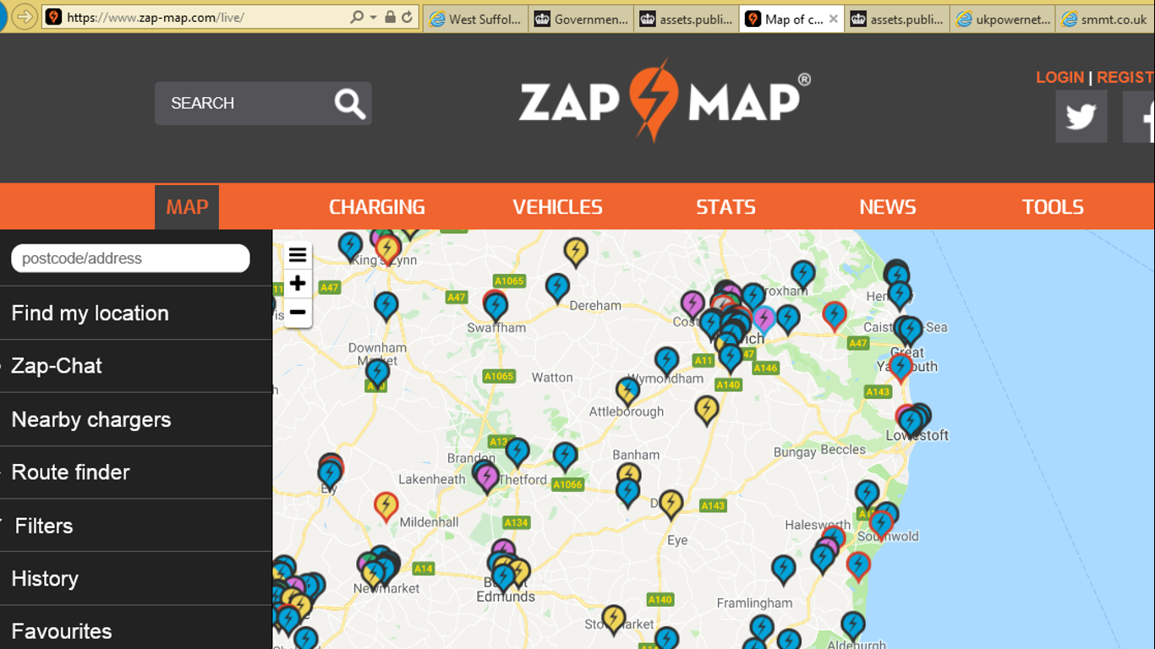

Figure 1: EV charging locations – Norfolk/Suffolk area

**Strategy for Eye**

Eye should take a positive strategic position in the EV charging network to accommodate three future demand scenarios:

* **Passing tourist and through-commute traffic** – Eye’s location on the main route form the South-east to Norwich, the Norfolk Broads and the East Anglian coast means that it has the potential to act as a transit charging destination for tourists and those travelling for work by electric vehicle from the Bury St Edmunds and Ipswich conurbations and travellers coming via the A12/A14 onto the A140 towards Norwich.

A key additional benefit to developing rapid charging infrastructure is that Eye could be marketed to out-of-area travellers, allowing them to charge their vehicle whilst relaxing or exploring the town.

* **Local residential traffic** – there is no current data available to estimate the current or future uptake of EV by residents of Eye and the local area. However, without charging infrastructure, the uptake of EV will be stifled.
* **Local business traffic** – without any charging infrastructure in its key employment areas, businesses will not consider the cost benefit of using EV, whether in their passenger or commercial fleets.

The overall long term approach should be provision for home and destination charging which will in turn require residential and commercial developers to specify higher electrical capacity. In this period of transition while there is range anxiety, en-route charging should be provided.

**New development – policy proposals**

All new residential developments should have EV charging provision.

All new commercial development should have EV charging provision with speed and number of connections dependent on the scale and type of development undertaken. This provision should create a mix of connection points particularly in employment areas, with rapid charging potentially made available to the public in specific circumstances e.g. at hotels, public facilities, commercial developments over a certain size. As a minimum to accord with Suffolk County Council standards, 5% of all non-residential parking places should include an Electric Vehicle recharging point.

**Existing development – policy proposals**

Charging of EV in existing parts of the town should comprise of a blend of provision with the following opportunities identified for installation over the short to long term such that the three future demand scenarios are fully served:

1. **Households with off-street car parking**– this should be promoted to existing residents. Residents with off-street private parking already have access to grant support[6] which provides grant funding of up to 75% towards the cost of installing electric vehicle charge points at domestic properties across the UK.
2. **Households without off-street car parking** - Provision should be made to give residents with no off-street private parking appropriate access to charging points.

Home charging presents difficulties in areas where residents have no off street parking (i.e. no private driveways). Lamppost-mounted charge points have a number of advantages over standalone points:

• No new street furniture/clutter

• Much cheaper installation costs

• The flexibility to change locations should demand be recognised in alternative locations.

[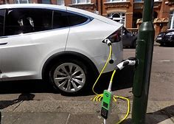](https://www.bing.com/images/search?view=detailV2&ccid=rVSZ3hQl&id=28F8E5EB91B9449E72851043CFEBA2F3BA569D57&thid=OIP.rVSZ3hQlDhe-aGNSCuxWTwHaFj&mediaurl=http://i.dailymail.co.uk/i/pix/2017/06/16/12/4176A34200000578-4607870-Bright_idea_Instead_of_installing_standalone_charge_points_a_Ger-a-1_1497611141005.jpg&exph=476&expw=634&q=street+lighting+ev+charge+points&simid=608037234192155068&selectedIndex=1)

Figure 1: Light column-fitted electric vehicle charge points[7]

These chargers will provide a slow (standard) charge that is suitable for residents who can ‘plug in’ overnight or other long periods whilst at home. Siting in the public car parks in Eye could give access for nearby residents to this low carbon, less polluting and cheaper form of transport, which will in turn help to improve local air quality and make Eye a more attractive place to live.

Using available national[8] blended with commercial investment and local[9] funding could also make the installations financially sustainable in the long term. The Cross Street and Buckshorn car parks provide likely installation points in existing lighting columns. Given the central location of the existing lighting columns several bays would be served increasing accessibility.

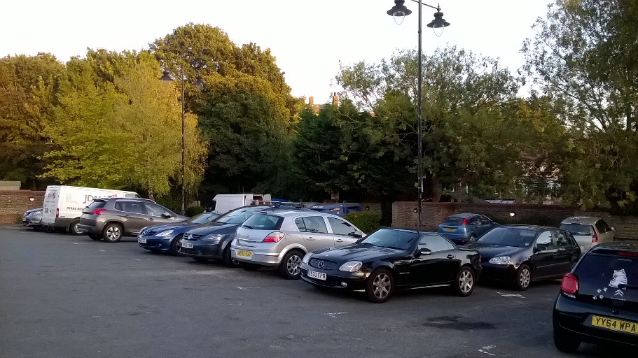

**Figure 1: Buckshorn Lane car park**

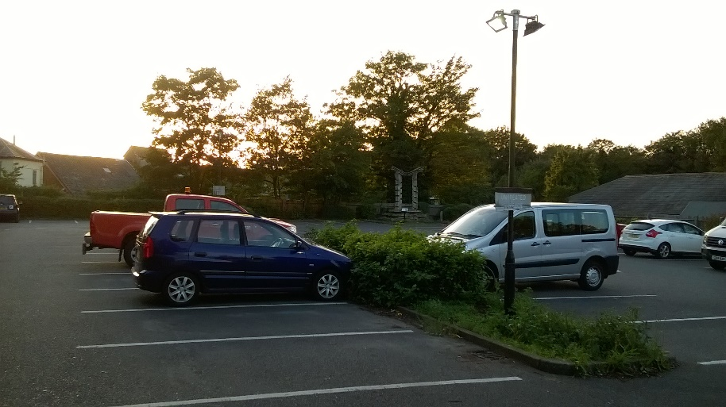

**Figure 2: Cross Street Car park**

The Cross Street car park is situated adjacent to an 11kV UK Power Networks sub-station. Enquiries to Mid Suffolk District Council has revealed that this could be accessed to provide rapid charging provision subject to the relevant agreements and funding. A blend of national and local funding could make the installations financially sustainable in the long term.

1. **Employment areas** – employers should be supported to install a range of charging connections to facilitate the uptake of EV amongst their employees and also their business fleets (i.e. passenger and light commercial vehicles). A blend of national[10] and local funding could make the installations financially sustainable in the long term.

Many technical, legal and financial challenges existing to achieving this strategy for Eye. Support is therefore sought in the first instance through the Neighbourhood Planning route in order to build awareness of the opportunities, start engagement with key stakeholders and gain support for further exploration of the opportunities.

1. <https://www.gov.uk/government/publications/reducing-emissions-from-road-transport-road-to-zero-strategy>
2. Zapmap
3. European Alternative Fuels Observatory
4. [www.ukpowernetworks.co.uk/internet/en/have-your-say/documents/EV%20Presentation_2018.03.13_V0.1](http://www.ukpowernetworks.co.uk/internet/en/have-your-say/documents/EV%20Presentation_2018.03.13_V0.1)
5. Zapmap, <https://www.zap-map.com/charge-points/>
6. The Electric Vehicle Homecharge Scheme available through the Electric Vehicle Homecharge Scheme (EVHS)
7. Source: Ecotricity
8. The On-Street Residential Grant Scheme available through the Office of Low Emission Vehicles (OLEV)
9. E.g. Community Infrastructure Levy, Local Large Scale Renewable Energy schemes providing community-directed funding, locality funding, crowd-funding
10. The Workplace Charging Scheme available through the Office of Low Emission Vehicles (OLEV)