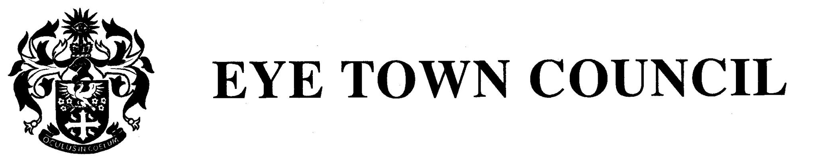

Councillors are hereby summoned to attend the
ANNUAL MEETING OF EYE TOWN COUNCIL to be held in the Council Chamber, Eye Town Hall,
on Wednesday 15th May 2025 at 7.30pm

- Election of Mayor for 2025-26
a. Declaration of Acceptance of Office to be signed

- Election of Deputy Mayor 2025-26
a. Declaration of Acceptance of Office to be signed

- Apologies and approval of absence(s)

- Members Declarations of local Interests and Consideration of Requests for Dispensations

- Public Forum
a. County Councillor Report – Cllr. Henry Lloyd
b. District Councillor Report – Cllr. Lucy Elkin
c. Members of the Public – to receive questions and matters of concern from those present.

Meeting to be closed for public participation. Formal Council statutory business as follows: -

- To receive and confirm the minutes of the Full Council Meeting on the 23rd April and the Annual Town Meeting held on the 30th May 2024.

- Committee structure
a. Agree the proposed standing committees

- To receive and comment on planning applications appeals and consideration of late applications.
No applications were received.

https://planning.baberghmidsuffolk.gov.uk/online-applications/ Search by the reference number.

- To receive and note Determinations received since the last meeting.
- DC/25/01582|Notification of Works to Trees in a Conservation Area - Reduce 1 No. Cherry (T1) by 25-30%|18 Church Street Eye Suffolk IP23 7BDRaise No Objection
- DC/24/05567|Planning Application. Change of use and conversion of commercial unit to form 1No dwelling, including demolition of existing single storey rear extension.|Lawrence House Magdalen Street Eye IP23 7AJRefused

- To receive an update and recommendations from the Environment Committee meeting.

- To receive an update and recommendations from the Finance and Governance Committee meeting.

- To receive an update and recommendations from the Town Hall and Events Committee meeting.

- Council to discuss and resolve: HGV traffic in Eye referring to rescinding the ETRO, permission to seek judicial review or to go via the Ombudsman

- Price list for the Town Hall
- Council to approve revised price lists. Changes to be implemented immediately.

- Youth Council next meeting date and awards (Cllr. Walker)

- To receive and confirm the following Financial Matters:
- To receive and note the current bank balances.
- To receive and approve invoices presented for payment for April 2025.
- To note payment of Staff Salaries for April 2025 by bank transfer payable on the 15th
May 2025.
d. Reserves report
e. Internal Audit for 2024-25 Year End
f. Year End 2023-2024
i. Council to approve the Annual Governance Statement 2024-25 (section 1)
ii. Accounting Statements 2024-25 (section 2)

- To consider or note items of correspondence not already circulated

- Date of next meeting Wednesday 18th June 2025.

- Meeting closes

