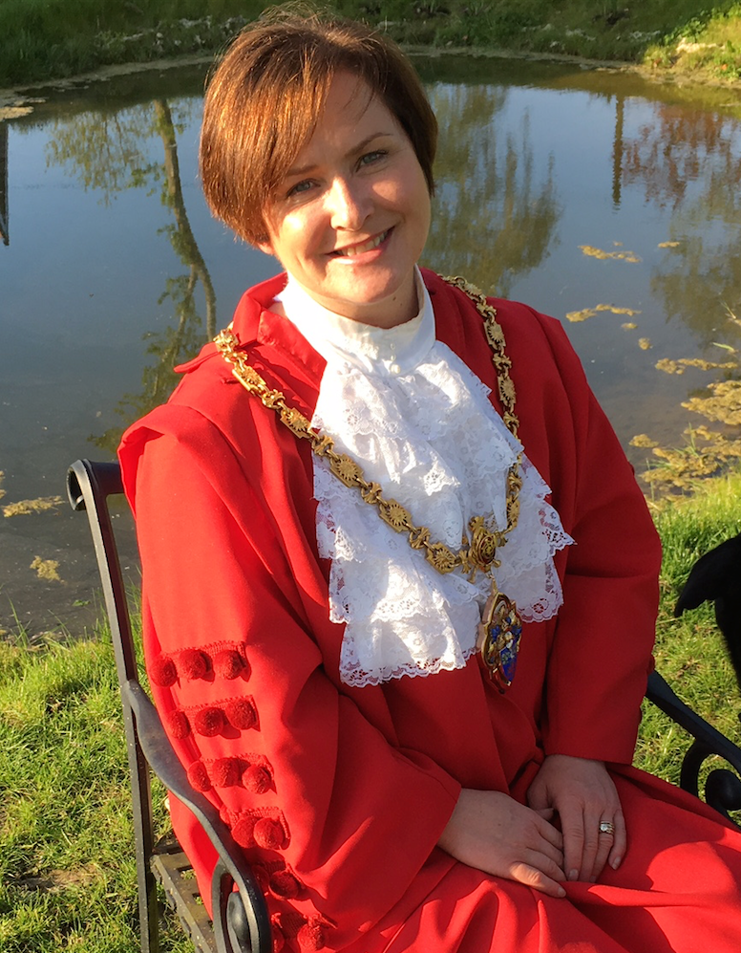

Comment from the
Mayor, Cllr Maria Ford

The past year appears to have flown by and soon I shall be handing over the chains of office to the Mayor Elect, Cllr Colin Ribchester. I was rather reluctant to take on the role of Mayor a year ago however as I reflect upon my year I can honestly say that I am honoured to have walked in the footsteps of so many before me.
Two major areas of concerns that came to light in the last 12 months are the application for 280 new homes plus a 60 bed care home on Eye airfield, and the issue of safety at the junction where the B1077 meets the A140, on the way out of Eye to Diss. These issues have yet to be resolved however the Town Council will continue to monitor these and all matters relevant to the residents of Eye.
One of the most heart-warming undertakings in my role has been to witness the involvement of local volunteer groups and organisations in the Town. I am humbled at the time so many busy people give to make others feel included and needed; I have met with many elderly people, school children and disadvantaged individuals and it has been a joy. The seemingly effortless way the volunteers assist in making someone’s day is inspiring. This also runs true for the individuals who find time to tend our green spaces, helping to maintain them as a haven for wildlife and walkers alike.
It is a fact of life that the Town Council is continually being asked to take more responsibility away the District and County Councils. I am pleased and fortunate to work with a dedicated group of Councillors who strive to do their best as representatives of the residents of Eye. I am also grateful to Roz Barnet, our clerk, for her diligence and cheery disposition.
Thank you to all who have supported me in my role as Mayor, the clerk, Councillors and residents. I couldn’t have done it without you.
Civic Awards

We are blessed in Eye to have so many active citizens who take great interest in the Town. This year we had a number of very worthy nominations for our Civic Awards.

2016 Civic Awards winners are:
- Chris Willoughby for his work on the Eye Magazine and his leadership of the Town Moors Society.
- St John Perry who is the bell ringing ‘Tower Captain’ and for his involvement with numerous Eye organisations.
- Richard Muttock for supporting the annual Remembrance Service for many years.
- Robin Knight for his work on setting up the speed watch group and organising the 20’s plenty campaign.
- Tony Diamond for supporting the Memory Lane group and organising the Christmas community singing.
- Bruce Salter for Chairing the Business Forum and for his support for Town events.

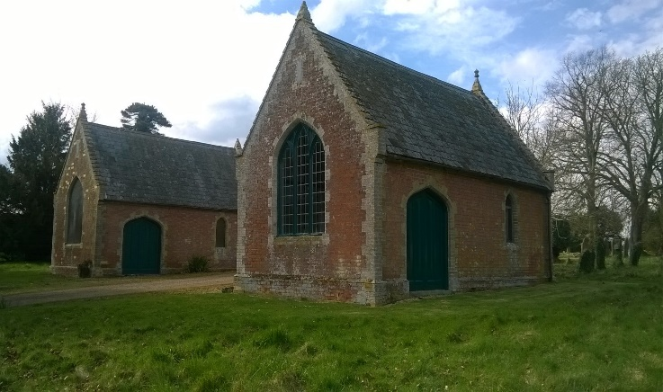
The newly renovated chapels

Town Council Activities
The Town Council comprises 15 individuals including the Mayor, who is Chair. Many issues and concerns brought to full Council are first addressed by committees made up of Councillors, and in some cases other interested parties and individuals. These committees are often required to undertake research or preparations in order to furnish full Council with necessary information and facts. Committee meetings are open to the public.

Planning Committee
The Planning Committee is chaired by Cllr Andrew Evitt and meets on the Monday before the full Council meeting. Last year the Planning Committee reviewed and made recommendations on 43 planning applications. The Town Council has also engaged residents in a consultation regarding planning application 3563/15, a proposal for 280 dwellings and 60 bed residential care home on the Eye Airfield. The Council has made it a priority to raise concerns and represent the views of residents in communications with Mid-Suffolk District Council and with the developer.

Environment Committee
The Environment Committee chaired by Cllr Cooper oversaw a range of work including: -
- The completion of £47,665 worth of improvements to the Town’s Street lighting. These improvements will allow the Council to make significant energy savings in the future.
- Repaired the road to the cemetery.
- Began to tackle dog fouling in the Town.
- Consulted over the 20-mile zone.
- Repaired the chapels at the cemetery.

Buildings Committee
Cllr Richard Berry chaired the Building’s Committee in 2016/17. Over the last year the exterior of the Town Hall has been decorated and the entrance foyer refurbished to make it more welcoming. The builders have replaced broken and damaged slates from the roof over the main hall but major investment is still required to improve the weather tightness and thermal efficiency. The first wedding has been held, with more booked, and hire bookings for the premises have roughly doubled over the year. The long sword event was a great success attracting people from all over England to the Town.

Our challenge is to continue to expand new business for the premises, however the layout and condition of the toilets is off putting to many prospective hirers. The ambition for the coming 12 months is to seek external funding to improve these facilities along with the kitchen, to have better access for people with a disability and to renew the roof over the main hall. We realise we are competing for scarce resources but we will compile a high quality application so that, if it is successful, we can aim to deliver much needed further improvements.
In the coming year the Building Committee will be changing to a Town Hall User Development Committee. This committee will focus on day-to-day management and work to increase the use of the Town Hall. A separate working group has been formed to raise significant amounts of money to replace the roof and refurbish the rest of the building.
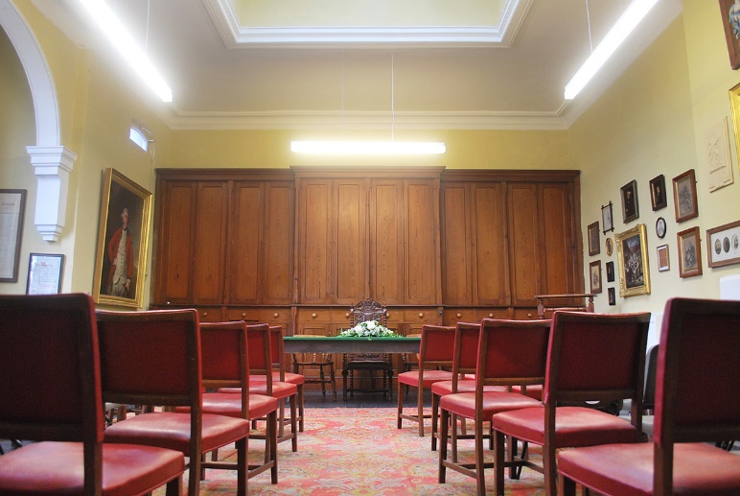
The Council Chamber ready for a wedding
Events and Marketing Committee

The Events Committee, which is chaired by Cllr Maria Ford, is made up of community members and Councillors and has had another busy year. Activities included;-
- Mayor Making in June which introduced the New Mayor with a Parade and Church Service.
- The Remembrance Day Service and Parade, which was well supported by the Town.
- The Eye Spring Clean, which was helped this year by the Women’s Institute who did a ‘Clean for the Queen’ event.
- Improving the Christmas lights in partnership with the business forum.
- A programme of free events held in the Town Hall, which was possible through funding from an Awards for All grant.
- Commissioning original artwork for use in marketing, by holding a photographic competition.
- Commemorating Commonwealth Day with participation from staff and pupils at Ss Peter & Paul Primary School.
- Celebrating Her Majesty’s 90th birthday with an event at Eye Castle and the lighting of the beacon.

Cllr Harley Molesworth has continued to update and improve the website which is vital for promoting the Town and events.
Remembrance Parade 2016

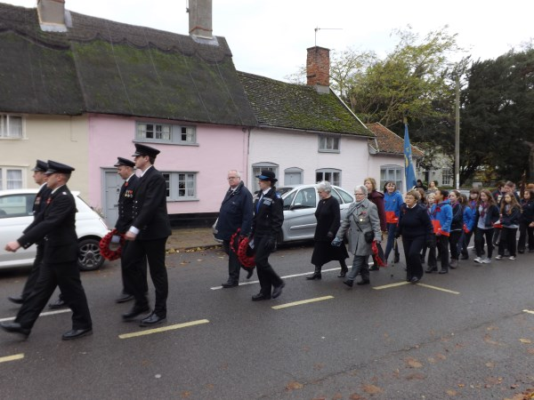

Strategic Committee

Cllr Gould continues to chair the Strategic Planning Committee at a time of momentous changes to the Town. The Strategic Planning Committee have achieved the following in the last year:-
- Engaged with Mid-Suffolk District Council and Suffolk County Council at a strategic level about future development in Eye.
- Established ‘The Eye partnership’ which is a collaborative working group with Mid Suffolk District Council and the County Council. The focus of the partnership is sharing intelligence about Eye with the County and District Council with a view to improving the future of Eye together.
- Secured £11,500 of external funding which will enable the Town Council to employ a consultant to undertake research and to engage in community consultation in relation to developing the joint project.
- Lobbied Suffolk County Council for improvements on the A140.
- Secured £1200 of external funding to rent an office in the Town for the Town Clerk.

Finance & Governance Committee

The Finance and Governance Committee is the backbone of the Town Council’s Committees and is led by Cllr Nancy Ford. This Committee ensures the Council is legally compliant and efficiently run within existing resources. This year the Committee undertook the following activities;-
- Set the annual budget.
- Reviewed and updated a number of policies and procedures for the Council to ensure it operates efficiently and legally.
- Reviewed the Town’s risk assessments.
- Oversaw the appointment of the new caretaker.
- Worked towards a foundation quality mark for the Council.
- Made information about the work of the Council more accessible to the wider community by ensuring that agendas and meeting minutes are published on the Council’s website.

The Town Council is always looking for residents to get involved and help improve the Town. If you would be interested in working on one of the committees please contact the clerk.

All correspondence with the Town Council should be addressed to the Town Clerk - Roz Barnett c/o Eye Volunteer Centre, 20 Broad St, Eye IP23 7AF, Tel 07713 196251 Email: Townclerk@eyesuffolk.org
The Councillors on Eye Town Council
Mayor
Maria Ford | maria.ford@eyesuffolk.org | 01379 870466
Mayor Elect
Colin Ribchester | colin.ribchester@eyesuffolk.org | 01379 871418
Deputy Elect Mayor
Harley Molesworth | harley.molesworth@eyesuffolk.org | 07725 584808
Councillors
Richard Berry | richard.berry@eyesuffolk.org | 07932 550362
Caroline Byles | caroline.byles@eyesuffolk.org | 07515 730097
Alan Cooper | alan.cooper@eyesuffolk.org | 01379 870828
Andrew Evitt | andrew.evitt@eyesuffolk.org | 01379 870926
Charles Flatman | charles.flatman@midsuffolk.gov.uk | 01379 871145
Nancy Ford | nancy.ford@eyesuffolk.org | 01379 870075
Peter Gould | peter.gould@eyesuffolk.org | 07740 595375
Simon Hooton | simon.hooton@eyesuffolk.org | 01379 871494
Jane Hudson | janehudson24@eyesuffolk.org | 07867 555308
Mick Robins | mick.robins@eyesuffolk.org | 01379 871469
Mike Smith | mike.smith@eyesuffolk.org | 07860 473518

Staff News

Sadly our very helpful Town Hall caretaker Barry Beamish left the Council in April after many years of service. Barry will be missed and we wish him well in his future pursuits.

We are pleased to announce that Stephen Smith has been appointed as Town Hall premises manager/caretaker. Stephen is Eye born and bred and knows the Town Hall well. He remembers helping his father carry out maintenance on the hall when he was a youngster.

Susan Kaye continues to do excellent work keeping the streets of Eye clean and tidy despite an increase in fly tipping in the Town.

Dawn and Karl Rouse are the caretakers for the public toilet in Cross Street and together they do a fantastic job in keeping the facility open.

Roz Barnett the Town Clerk now has an office in the volunteer center which is open to the public on Mondays 10.30 am -1.30 pm.

The Mayor presents Barry with a certificate to mark his service to the Town.

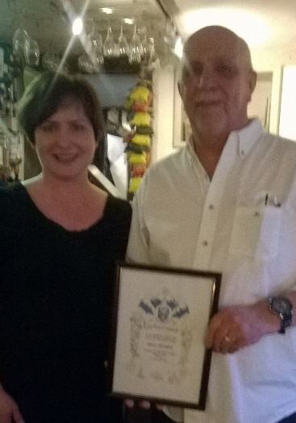

Eye Town Council Accounts - Year End March 2016 - Receipts and Payments
 | 31st March 2015 |  |  | 31st March 2016
Precept | £70,500.00 |  | Precept | £73,957.51
Precept Grant | £6,450.50 |  | Precept Grant | £4,300.33
VAT | £2,433.47 |  | VAT | £16,607.33
Town Hall | £6,555.19 |  | Town Hall | £8,585.87
Cemetery | £2,024.20 |  | Cemetery | £3,604.00
Allotments | £1,374.75 |  | Allotments | £1,512.10
Stallage | £1,700.00 |  | Stallage | £1,372.00
Sect 106 | £5,000.00 |  | Sect 106 | £-00
Bank Interest | £243.12 |  | Bank Interest | £258.06
Grants | £49,592.40 |  | Street Cleaning Grant | £7,041.60
 |  |  | Loan | £19,975.00
 |  |  | Grants | £6,076.65
TOTAL RECEIPTS | £145,873.63 |  | TOTAL RECEIPTS | £143,290.45
Salaries | £30,011.41
Town Hall | £7,052.59 |  | Town Hall | £41,542.12
Cemetery | £5,531.82 |  | Cemetery | £7,236.50
Allotments | £1,316.05 |  | Allotments | £435.36
Administration | £4,674.38 |  | Finance and Governance | £23,882.16
Highways | £7,379.48 |  | Highways | £12,433.15
Insurance | £4,712.41 |  | Insurance | £2,856.00
Donations/Section 137 | £11,487.40 |  | Donations | £1,200.00
Community Centre Loan | £6,014.68 |  | Community Centre Loan | £6,014.68
Mayor Activities | £677.75 |  | Toilet | £4,764.64
Pocket/Skate Park | £1,034.62 |  | Parks | £876.97
VAT | £3,511.12 |  | VAT | £17,003.94
Other Council Activities | £17,466.88 |  | Events | £3,709.72
 |  |  | Street Light Major Works | £37,746.33
 |  |  | Strategic Planning | £2,268.25
 |  |  | Awards for All | £6,531.94
TOTAL PAYMENTS | £100,870.59 |  | TOTAL PAYMENTS | £168,501.76
RECEIPTS & PAYMENTS SUMMARY |  |  | RECEIPTS & PAYMENTS SUMMARY
Balance as at 1st April b/f | £72,568.42 |  | Balance as at 1st April b/f | £117,571.46
Total Receipts | £145,873.63 |  | Total Receipts | £143,290.45
Less Payments | £100,870.59 |  | Less Payments | £168,501.76
Balance as at 31 March c/f |  | £117,571.46 | Balance as at 31 March c/f |  | £92,360.15
BANK RECONCILIATION 31 MARCH 2015 |  |  | BANK RECONCILIATION 31 MARCH 2016
Current Account | £20,201.06 |  | Current Account | £4,377.69
Less Unpresented Cheques | £554.00 |  | Less Unpresented Cheques | £200.00
Accounts Balance C/F |  | £19,647.06 | Accounts Balance C/F |  | £4,177.69
Business Account |  | £67,925.10 | Business Account |  | £57,958.16
National Savings Account |  | £29,999.30 | National Savings Account |  | 30,224.30
 |  | £117,571.46 |  |  | £92,360.15

