PROPOSAl
We are hoping to send a few students to the eye care home for our citizenship project to connect Hartismere to eye town.

RESEARCH
We sent out an email to the care home and didn’t get a response so we contacted mrs findlay the head of year and she is sending out a email to the care home
And is waiting for a response
We also sent a google forms quiz to year 7 to see if they would be up for going to the care home and if they had any ideas but once again we didn't get a response

School has never visited Hartismere place care home.
The primary school has been but not Hartismere.

0330 165 1330

30 march.
Email sent to the care home asking if we can visit
Google forms being sent to year 7 to see if they think Hartismere is connected to eye community and what could be done to connect it better.

19 april.
We didn’t get a response from the care home and have now sent an email to ask the head of year and the head of school whether we would be able to arrange a visit.

To do list
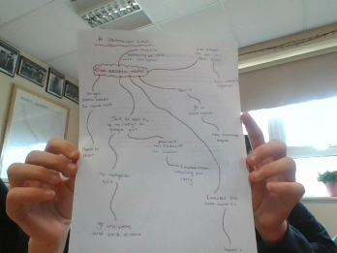

27 april
Contacted and then spoke to Mrs. Findlay to ask if it would be possible to send some students to Eye care home. She said that she would contact the care home to see if a visit would be possible. Also sent an email to miss buttle because miss driscoll said she would be up for doing something like that

3 may
No reply from miss buttle and mrs findlay hasn't had a response from the care home either yet.

15 july
Emailing miss findlay and also planning a date to go to the care home

